1 . **tutorial**

YouTube，Quora: **WeChat mini program**

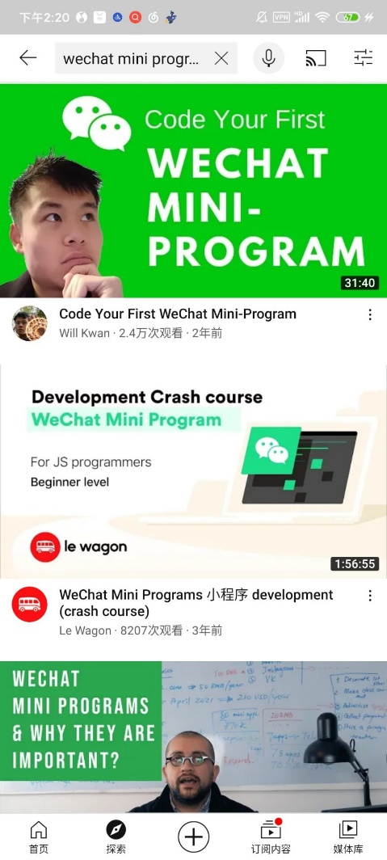 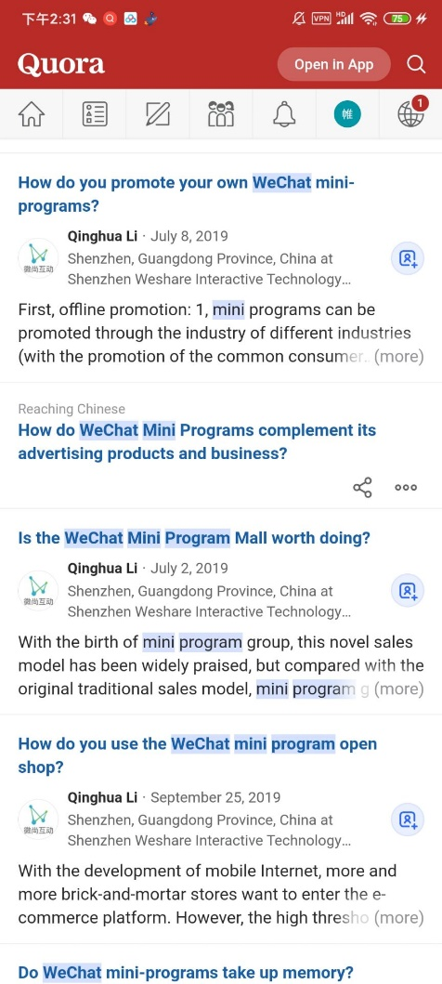

WeChat Official Document:

<https://developers.weixin.qq.com/miniprogram/en/dev/framework/>

Actually, there are a variety of templates to use and a large number of functions that are ready to go and the way to use these templates is really easy (by dragging, copy and paste), but they are inflexible, we still need to develop it by ourselves.

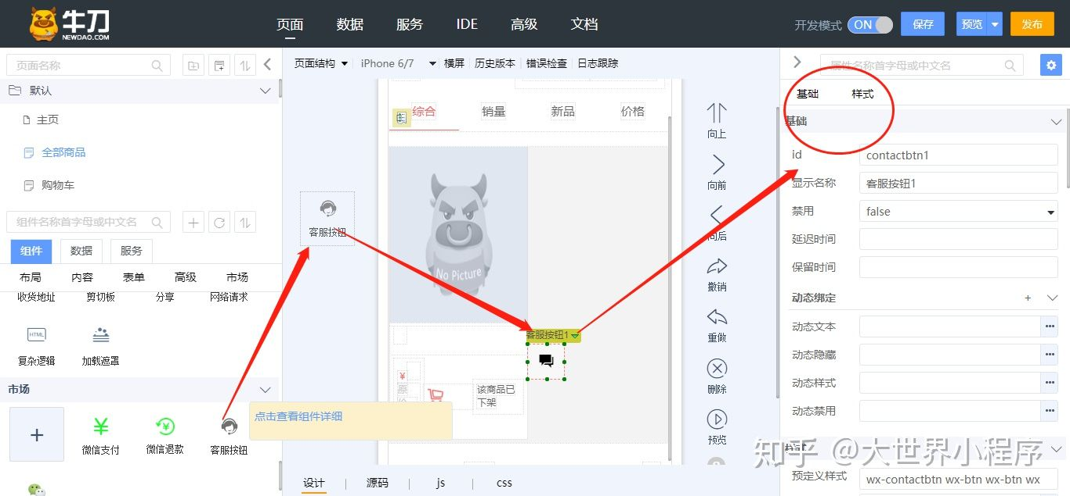

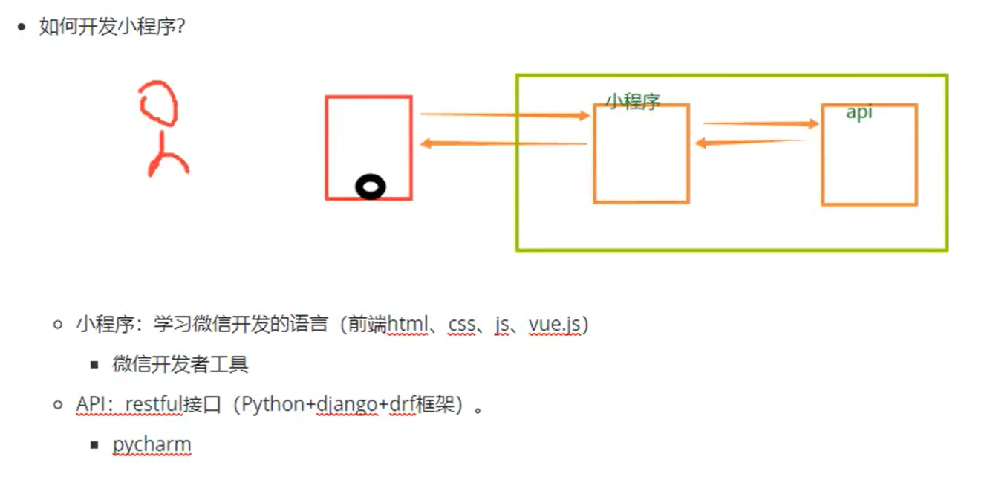

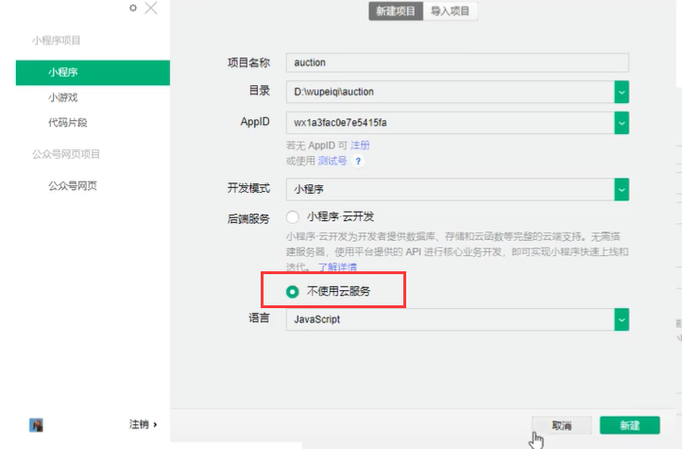

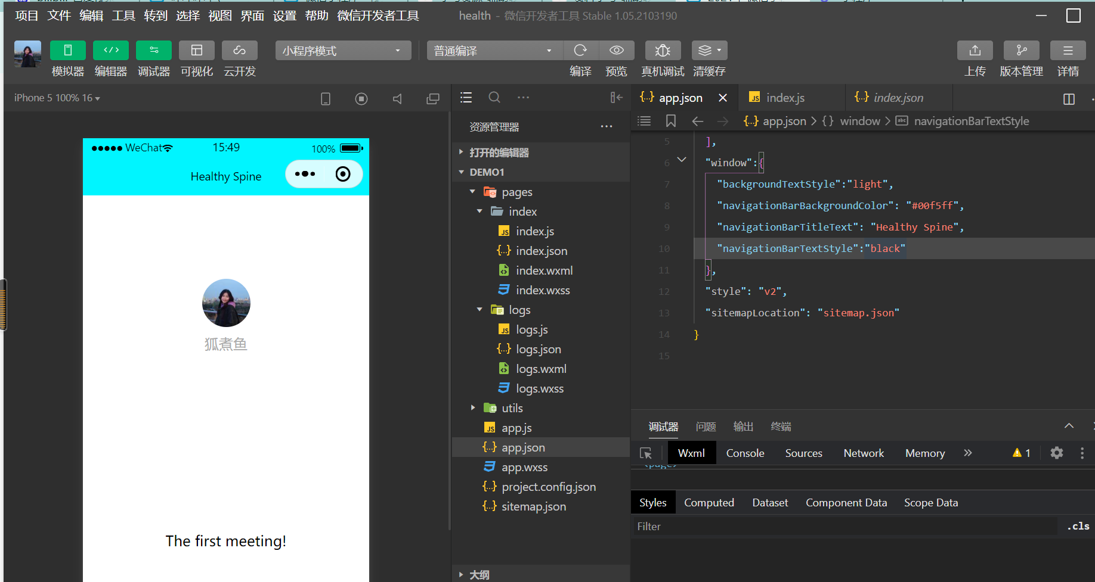

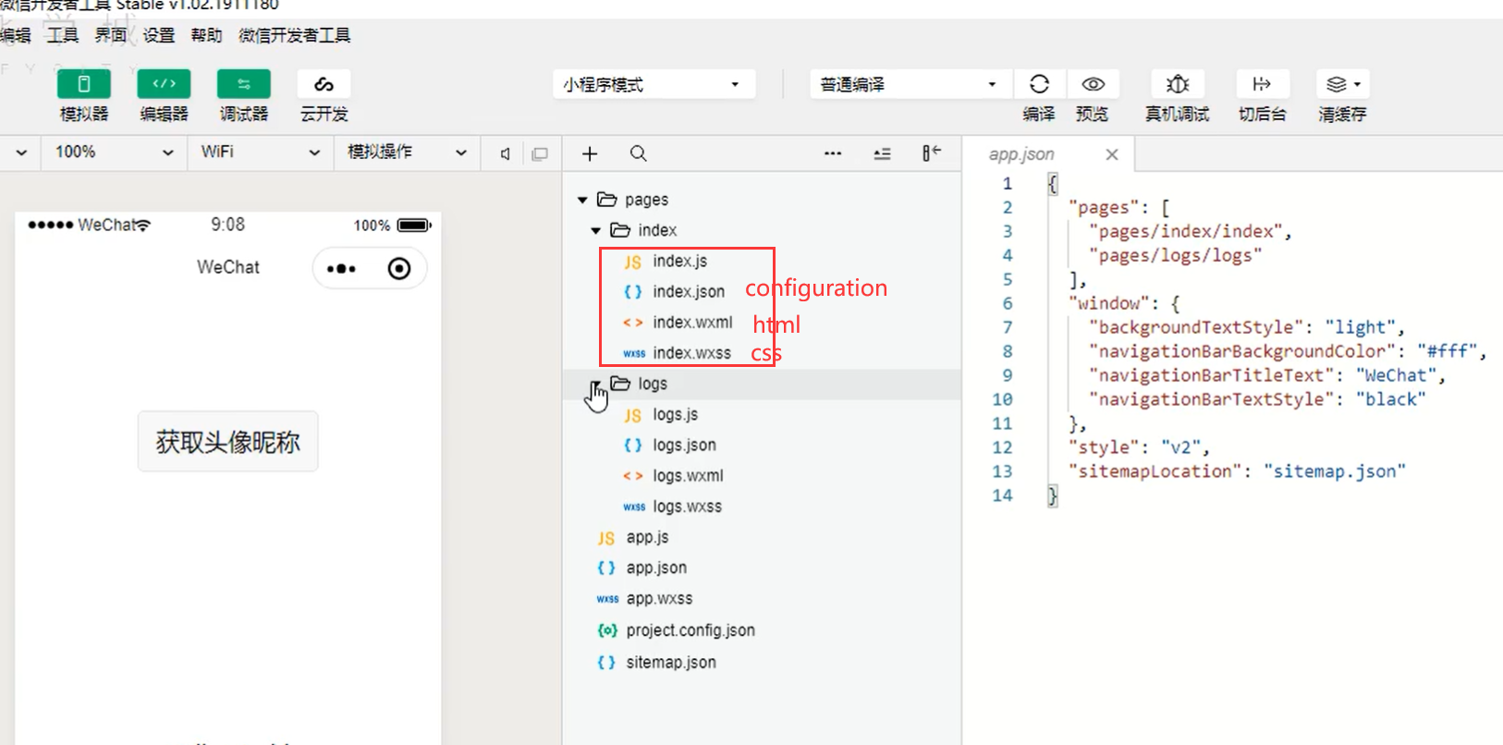

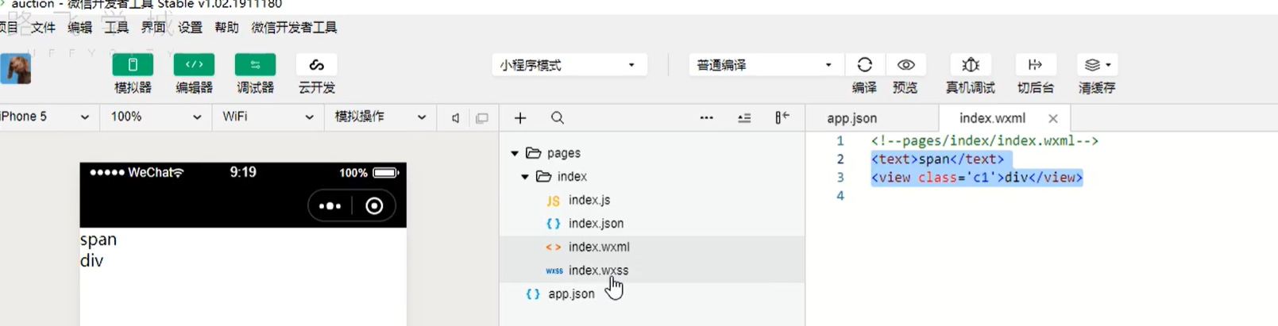

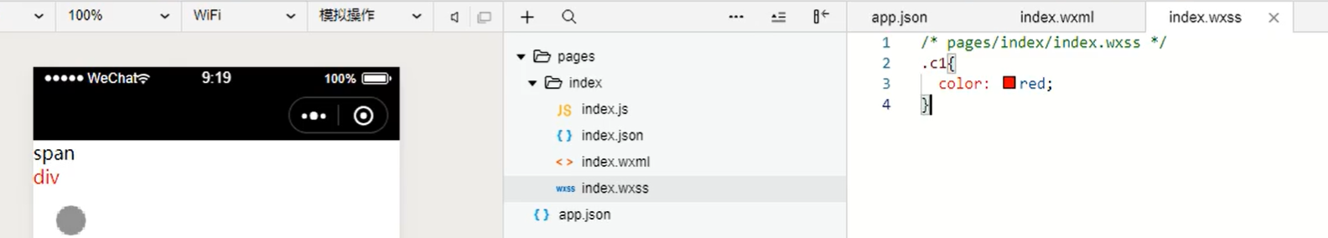

* Switch between Chinese and English（for later possible use）

<https://blog.csdn.net/weixin_41597254/article/details/113782408>

2. Example of mini program

(sorry I cannot find any mini program with English version, maybe the major market of mini programs is in China…)

Here are some examples of hospital applets:

1. General layout of home page
2. Treatment record page

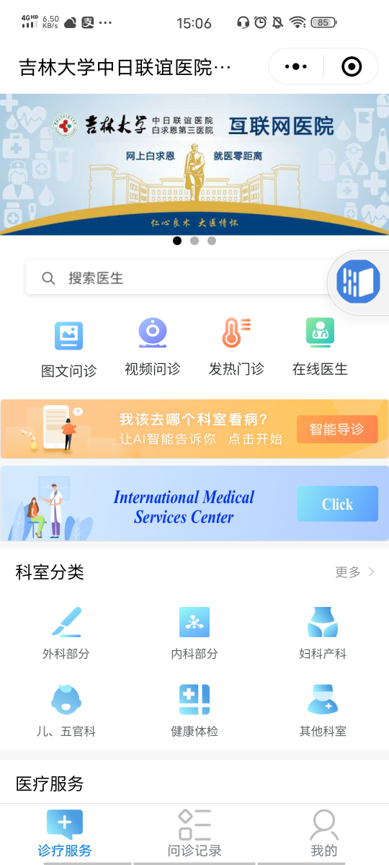 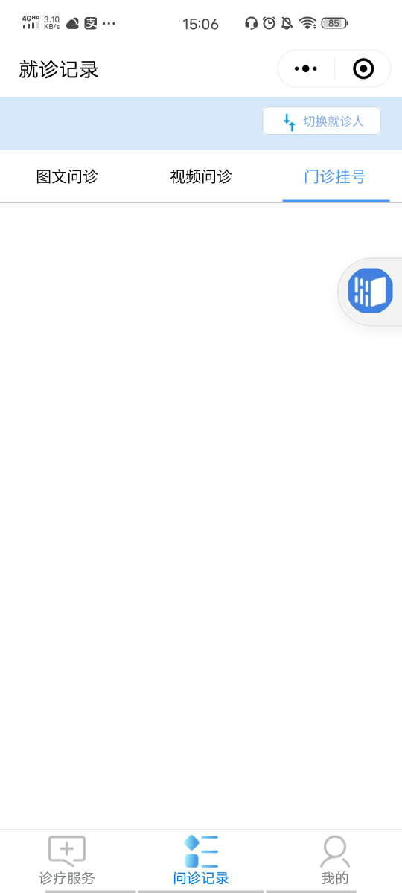

Our major task is to design suitable functions for patients, doctors to administrators to use. (including relative UI design) 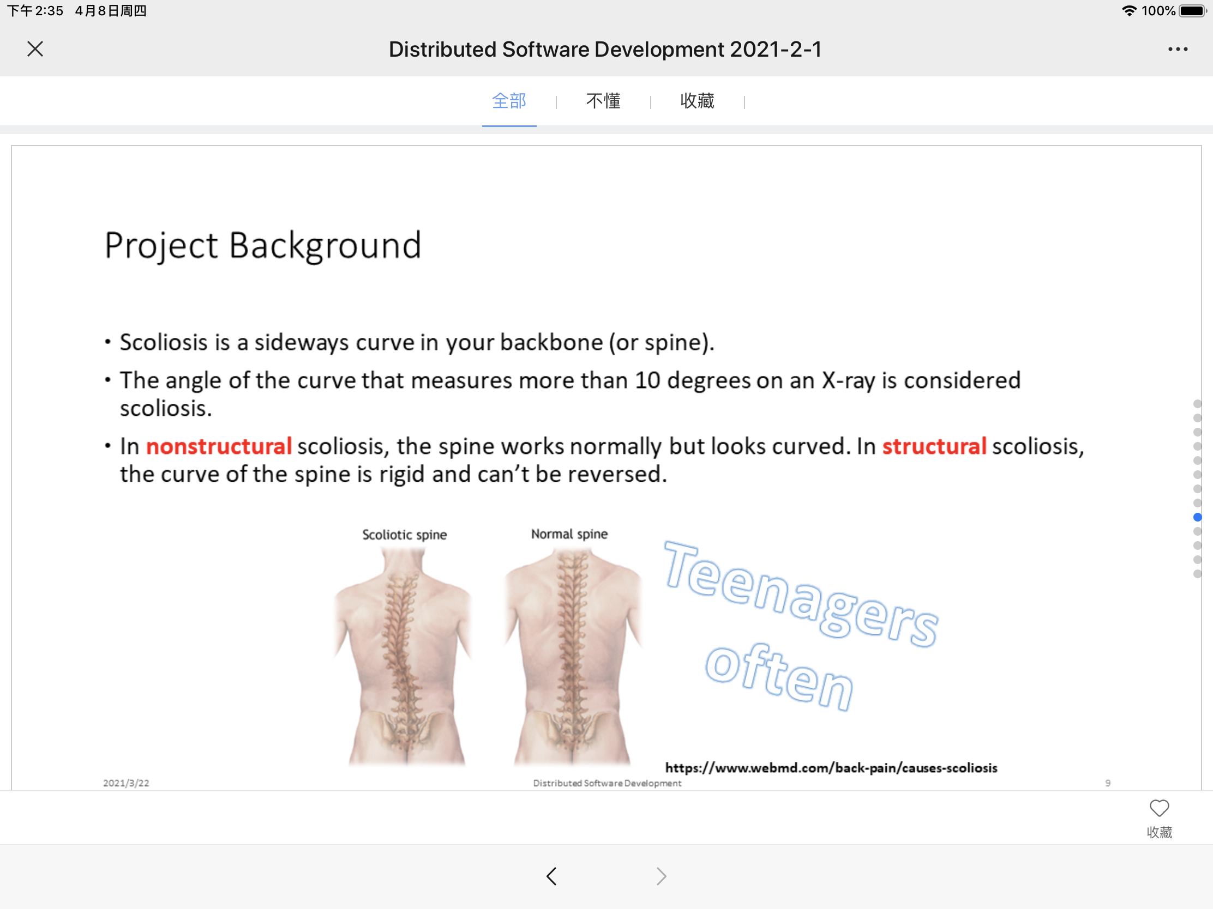

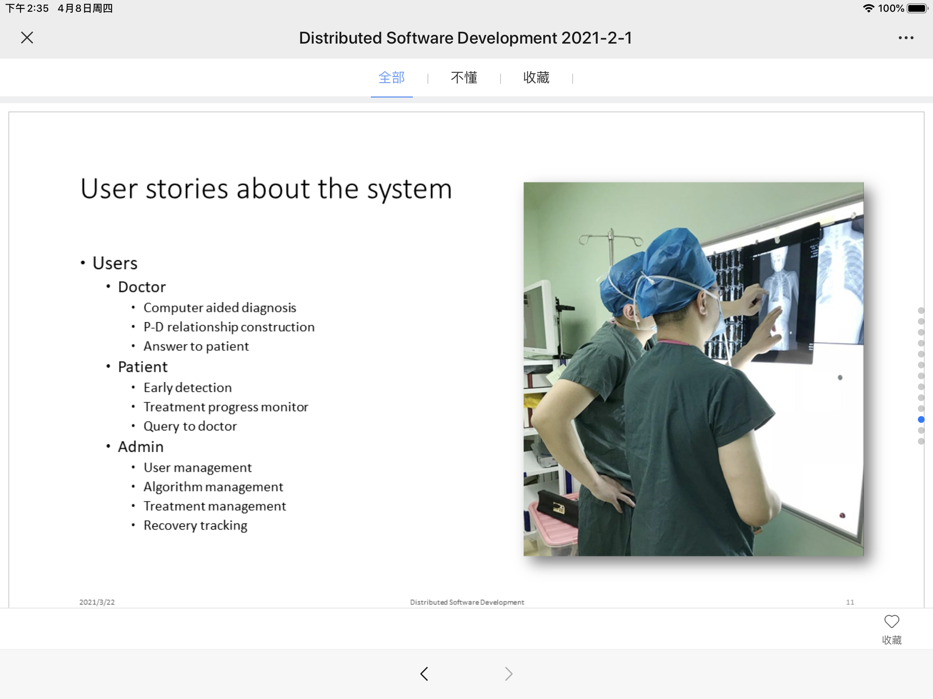

**Tester**: start to think about test cases (Automated test cases are better)

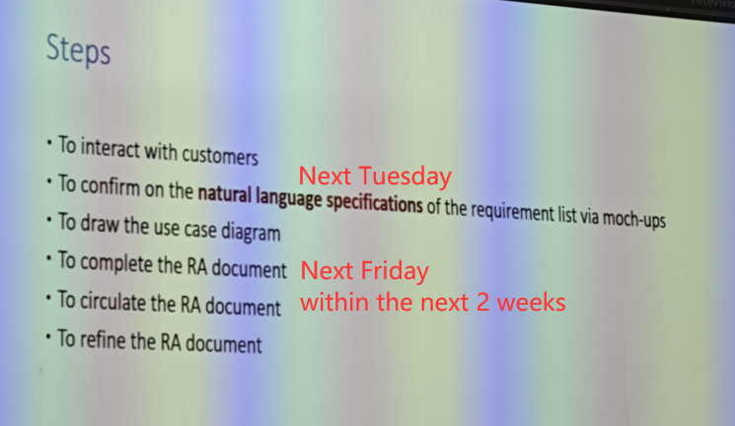

RA-SA (feasibility) Tester (relative test cases)

注册页面